Cass County Classic
Horse Show
Hosted by the Cass County Fair
July 10 – 11, 2021
Cass County Fair
590 N. O’Keefe St. / PO Box 56
Cassopolis, MI 49031
Phone: 269-445-8265
Email: casscountyfair@ gmail.com
Mycasscountyfair.com

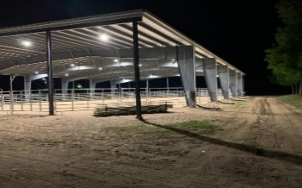
- Show Starts at 8:00 AM Rain or Shine. Office opens at 7:00 AM * Negative Coggins Required
Registration
Name: ______________________________________________________________________________
Address: ____________________________________________________________________________
City: __________________________________ State_________ Zip Code_____________
Cell Phone: __________________ Phone___________________ Email______________________ Horse #__________ Horse #________
Entry Fees | Amount | Description | Total Fee  Amount
Office Fee | $5.00
Class Fees | $7.00
Lead- Line |  | Free
Sweepstakes | $10.00
Blanket Fee | $45.00 | One Horse/ One Rider Combo  *This applies to Classes 1 – 65 Only  and Excludes Sweepstakes  *Exhibitor must choose between  Ranch & Western Division
Stalls | $35.00 | Covers Fri- Sun
Shavings | $6.50 | Can also purchase at show or bring your own
Camping | $25.00 | Per Day
Total Due

Method Of Payment- Office Use Only
- Cash
- Check Ck#___________
- Credit

Payment by Credit- Call the Cass County Fair Office @ 269-445-8265
All Checks should be made Payable to the Cass County Fair Association
All Proceeds will go to the New Covered Horse Arena!!!

